Problem Statement
A hospital bills each patient for three kinds of charges: consultation, diagnostic (tests, scans) and treatment. Some patients qualify for concessions, for example senior citizens and low-income patients. The bill must be checked for errors before it is issued. After the final amount is known, the patient is placed in a payment category that decides how they may pay.
Objectives
- Store each patient’s record as a tuple.
- Validate the data before billing.
- Calculate the subtotal from the three charges.
- Find and apply the correct concession.
- Calculate the net payable amount.
- Classify the patient into a payment category using the policy.
- Print a clear bill for every valid patient and an error message for every invalid one.
Assumptions
- Each patient record is a tuple: (patient_id, name, age, low_income, consultation, diagnostic, treatment). Here low_income is True or False.
- All amounts are in rupees (Rs).
- Concession policy (example values):
  - Senior citizen (age 60 or more): 10% off.
  - Low-income patient: 20% off.
  - High bill (subtotal above Rs 20,000): 5% off.
- Concessions do not stack. Only the highest applicable percentage is used.
- The concession can never be more than Rs 5,000.
- Payment policy (based on net bill):
  - Up to Rs 2,000: Category A, pay in full at the counter.
  - Rs 2,001 to Rs 10,000: Category B, pay in full or in 2 installments.
  - Above Rs 10,000: Category C, 50% advance deposit plus an installment plan.
- Validation rules: the name must not be empty, age must be between 0 and 120, charges must not be negative, and the total bill must not be zero.
- Invalid records are reported and not billed.
Algorithm
- Define the concession rules and the payment policy.
- Take the next patient record.
- Validate it. If there are errors, print them and skip to the next patient.
- Subtotal = consultation + diagnostic + treatment.
- Collect every concession the patient qualifies for (senior, low-income, high bill) and take the highest percentage (0 if none).
- Concession amount = subtotal × percentage / 100, limited to the maximum cap.
- Net payable = subtotal − concession.
- Compare the net amount with the policy limits in order and pick the first matching category.
- Print the bill with the subtotal, concession, net amount, category and payment rule.
- Repeat until all patients are processed.
Pseudocode
CONSTANTS: senior age, discount percents, high bill limit, max concession, payment policy

FUNCTION validate_patient(patient):
errors = empty list
IF name is empty: add "Name is missing"
IF age < 0 OR age > 120: add "Age must be between 0 and 120"
FOR each charge:
IF charge is not a number OR charge < 0: add error
IF no errors AND total = 0: add "Total bill is zero"
RETURN errors

FUNCTION find_concession_percent(patient, subtotal):
options = empty list
IF age >= 60: add 10
IF low_income: add 20
IF subtotal > 20000: add 5
IF options is empty: RETURN 0
RETURN maximum of options

FUNCTION classify_patient(net):
FOR each (limit, category, rule) in payment policy:
IF net <= limit: RETURN category, rule

FUNCTION process_bill(patient):
errors = validate_patient(patient)
IF errors not empty: RETURN invalid result
subtotal = consultation + diagnostic + treatment
percent = find_concession_percent(patient, subtotal)
concession = MIN(subtotal * percent / 100, max concession)
net = subtotal - concession
category, rule = classify_patient(net)
RETURN bill details
Test Cases
# | Test | Input | Expected result
1 | No concession | Age 35, not low-income, bill Rs 1,700 | 0% concession, net 1700, Category A
2 | Senior concession | Age 68, bill Rs 7,100 | 10% = 710, net 6390, Category B
3 | Low-income concession | Age 45, low-income, bill Rs 15,500 | 20% = 3100, net 12400, Category C
4 | High-bill concession | Age 50, bill Rs 39,000 | 5% = 1950, net 37050, Category C
5 | Concessions do not stack | Senior and low-income | 20% (highest only)
6 | Concession cap | Senior, low-income, bill Rs 60,000 | 20% would be 12000, capped at 5000, net 55000
7 | Boundary 2000 | Net bill 2000 | Category A
8 | Just above 2000 | Net bill 2000.01 | Category B
9 | Boundary 10000 | Net bill 10000 | Category B
10 | Just above 10000 | Net bill 10001 | Category C
11 | Missing name | Name is "" | INVALID: Name is missing
12 | Negative charge | Diagnostic = −300 | INVALID: charge must be non-negative
13 | Bad age | Age 130 | INVALID: age must be between 0 and 120
14 | Zero bill | All charges 0 | INVALID: Total bill is zero
15 | Wrong field count | Tuple with 5 fields | INVALID: Wrong number of fields
Output
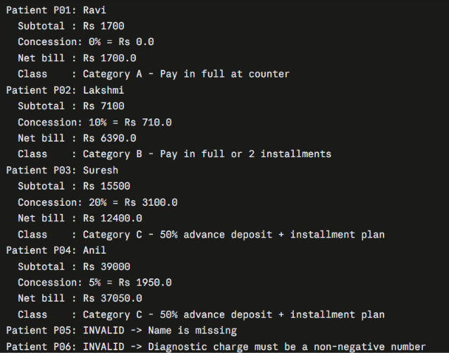
Flowchart
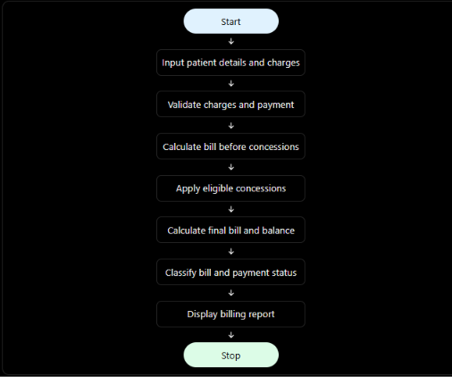
Conclusion
The program processes consultation, diagnostic and treatment charges, validates the patient data, applies the highest eligible concession (within the cap), and classifies each patient into a payment category from the supplied policy. In the sample run, four patients were billed and placed in Categories A, B, C and C, and two records were rejected for invalid data (a missing name and a negative charge).

